Belgrade 6 – Drop all charges!

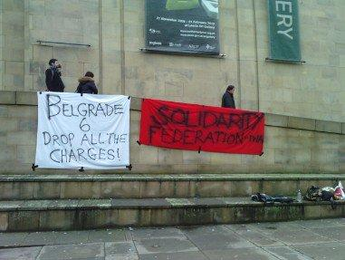

We would like to inform you that on the 8th February 2012, there will be a renewed trial against four members of the Serbian
Anarcho-syndicalist Initiative (ASI) as well as two unaffiliated
Belgrade anarchists, as part of the fabricated legal case of the
Belgrade Six (BG6).
The six Belgrade libertarians have been accused of inciting, assisting in and executing an attack on the Greek Embassy in Belgrade at the end of August 2009, in solidarity with a hunger-striking Greek political prisoner. Soon after the attack on the embassy, BG6 (Tadej Kurepa, Ratibor Trivunac, Ivan Savic, Ivan Vulovic, Nikola Mitrovic and Sanja Dojkic) were arrested and held in custody for the next six months charged with ‘international terrorism’. Thanks to a mass mobilisation of support, both globally and locally, they were released early before their trial date. In June 2010, they were finally fully acquitted at a High Court in Belgrade, which decided that there is no basis for a guilty verdict on any of the charges.
The prosecution filed a complaint, but the Court of Appeals failed to respond until a moment when suitable political reasons emerged. Only days after antimilitarist protests against the NATO summit that took place in Belgrade in June 2011, at which Ratibor Trivunac was arrested, the Court of Appeals granted the prosecution’s complaint and ruled on a renewed case against BG6.
Currently, there are criminal proceedings against seven members of the Belgrade local group of ASI and they are all politically motivated. The renewal of the case against the BG6 can only be seen as the continuation of state repression against those who stand up to pillage and exploitation. Bearing in mind that Serbia is a peripheral banana-state, ruled by a layer of compradorial bourgeoisie, it has been shown that in this phase of the struggle, the greatest force against the state repressive apparatus is international solidarity.
Therefore, we are calling all comrades and compañeras, anarcho-syndicalists, revolutionary syndicalists and class struggle anarchists everywhere to join in an international day of solidarity
with BG6, organised on the 6th February globally in front of the
embassies, consulates and cultural institutions of the Republic of
Serbia. The protests should carry a clear demand for the ending of alllegal proceedings against the Belgrade libertarians and the dropping of fabricated charges.
The freedom of our comrades depends largely on the activities of the international libertarian movement and we are convinced that
international solidarity will once again show its strength.
Freedom to the BG6!
Death to the state and capitalism!

